. |   APPLICATION FOR MEMBERSHIP  PART 1 OF 2  Schedule 1 (the Information Schedule) constitutes an integral part of this application form as it sets out the necessary requirements and instructions for the proper completion of this form and submission of your application. It is accordingly essential that you read and understand its contents and comply with the instructions. Kindly do so before you start filling in this form and before you direct any questions to the Cape Bar about the application process.  Your application comprises two parts: (a) this application form (part 1 of 2) AND (b) a signed and completed official applicant’s declaration (part 2 of 2). You must submit both.
  Attach
  ID photo
  here
  (Glued, not stapled, or electronically pasted)
 | I hereby apply for the following at the Cape Bar (pick one):
Click the appropriate checkbox. | ☐ | full membership  (incl. members holding memberships at other Bars)  or
Click the appropriate checkbox. | ☐ | associate academic membership  (available to full-time law teachers at UCT, US or UWC who have done pupillage)  or
Click the appropriate checkbox. | ☐ | associate membership  (only available to members practising in George/Knysna)
 | Name of applicant
- Full name(s) and surname:
………………………………………………………………...................…………………..……
(Official first, middle and last names, e.g. ‘Susanna Nosiviwe Zulu’)

- First name which you prefer colleagues to call you: …..…........…………………...…….…
(E.g. ‘Susan’)

 | Personal particulars of applicant
See information schedule paras 37-39.  You must provide an email address: correspon-dence will be sent to that address only. | - Home address: …………………………………….................…...........................................  ………………………………………………………………………………………….…………..  ………………………….....…….................................… Postal code: …..............................  Phone No: ...................................................... Cell: .........................................................  Email address: …………….......………………...………….................……..…………………
- Postal address: ……………...…………………………….....................................................

………………………………………………………………………………………….…………..

………………………………….........................… Postal code: …......................................

- Current employer: ……………………………………………………………………………….

Nature of employment: ………………………………………………………………………….

Work address: …………………………………………………………………………………..

……………………………………………………………………………………………………..

…………………………………..… Phone No: ………………………………………..………

Attach a letter of good standing from this Bar. | - If you are currently a member of another Bar:  - Name of the Bar: ..................................................................................................  - Do you keep chambers at this Bar? ☐ Yes ☐ No  - If you do not keep chambers, why not? .................................................................  ………………………………………………………………………….......……………..  - Physical address where you keep chambers:  ………………………………………………………………………….......……………..  ………………………………………………………………………….......……………..
 | - Date of birth: ……………………………………………………………………………………..
 | - Identity number: …………………………………………………………………………………
In respect of the questions on nationality, race, sex and disability, see information schedule para 40. | - Nationality:………………………………………………………………………………………..
  - If you are a South African citizen, how did you obtain South African citizenship?
☐ by birth or descent ☐ by naturalisation

  - If you are a South African citizen by naturalisation, on what date did you obtain South African citizenship? ..……......................……………………………….………

  - If you are not a South African citizen, provide full particulars of your immigration status and your right to reside in South Africa:

……………………………………………………………………………………………..

 | - Race: ☐ African ☐ Coloured ☐ Indian ☐ White
 | - Sex: ☐ Female ☐ Male
 | - Are you disabled? ☐ Yes ☐ No
 | If so, provide details: ………………………………..……………...…………..……...………..
- Do you need this application to be treated confidentially in regard to your current employer?
☐ Yes ☐ No

Admission as a legal practitioner and enrolment as an advocate

- Date of and division where you were admitted as a legal practitioner:

…….……………………………………………............................……………………………..

- Date on which you were enrolled as an advocate by the Legal Practice Council:

…….……………………………………………............................……………………………..

- Apart from the answers provided above, give particulars of any previous –

  - admission as a legal practitioner or application for admission as a legal practitioner:

………..…………………………………………………………………………………..

  - removal or suspension from the roll of attorneys or advocates:

………..…………………………………………………………………………………..

Also see para 20 below. | - membership of any Bar or application for membership of any Bar:  ………..…………………………………………………………………………………..
- Have you successfully completed all requirements of pupillage (including passing the NBEB examinations and completing the required period of pupillage)?

☐ Yes ☐ No

If no, provide full details of the outstanding requirements or your exemption:

………………………………………………………………………..…………………………..

………………………………………………………………………..…………………………..

………………………………………………………………………..…………………………..

Members from constituent Bars need not submit proof of pupillage. | - Have you attached proof of you having successfully completed all requirements of pupillage or having been exempted from any such requirement?  ☐ Yes ☐ No
- Will you be practising in the Western Cape / jurisdiction of the Western Cape High Court?

☐ Yes ☐ No

See relevant attachments in para 36.9 below. | - Are you or have you been a member of any Bar?  ☐ Yes ☐ No  If so, provide the following details, including any period of absence from practice:
  Name of Bar | Date membership started | Date membership ended
You are reminded to change your status of membership at the other Bars where you hold membership. | - Do you intend to take up dual membership (i.e. do you currently hold membership at another GCB constituent Bar and wish to apply for membership at the Cape Bar)?  ☐ Yes ☐ No  If so, at which Bar will you be paying your GCB membership (i.e. which Bar will be your main Bar after taking up membership at the Cape Bar)?  ……………..………………………………………………..........…
- If you are applying for associate membership (keeping approved chambers in George/Knysna), at which approved chambers do you intend to hold chambers?

………………………………………………………………………..…………………..………..

This will be included in your profile on the Cape Bar’s website. See the website for examples. | - What are your main fields of practice or interest (e.g. criminal law, labour law, family law, competition law)?  ………………………………………………………………………..………………..…………..  ………………………………………………………………………..………………..…………..  ………………………………………………………………………..…………………..………..  ………………………………………………………………………..…………………..………..
 | References
 | - Please furnish the name and contact details of two persons (preferably local persons) to whom the Cape Bar Council can refer:
  - Name: ……………………………..……………………………………………….…….

Address: …………………………………..………………………………….………….

………..………………………………………………………..…………………………..

 | Phone No: …………………………………………..………………..………………….
 | E-mail: …………………………………………………………......……………….…….
  - Name: ……………………………..……………………………………………….…….

Address: …………………………………..……………………………………….…….

………..……………………………………………………………………………….…..

 | Phone No: …………………………………………..………………………….……….
 | E-mail: …………………………………………………………………………......…….
……………………………………………………… …………………..……………
SIGNATURE OF APPLICANT DATE

SCHEDULE
(‘the information schedule’)

Membership of the Cape Bar

- The Cape Bar is a voluntary association of advocates. To be eligible for membership of the Cape Bar you must:
  - be duly admitted as a legal practitioner by the High Court of South Africa and enrolled as an advocate by the Legal Practice Council;
  - intend to practise as an advocate in the Western Cape;
  - be a fit and proper person for membership;
  - have successfully completed the admission examinations administered by the Legal Practice Council (if applicable to you);
  - have successfully completed the requirements of pupillage of the Cape Bar or having been exempted by the Cape Bar from any such requirement, which include having passed the NBEB examinations and having completed the prescribed pupillage requirements at the Cape Bar or at another Bar recognised by the Cape Bar; and
  - comply with the remaining requirements of the Constitution of the Cape Bar or determinations of the Cape Bar Council, such as those relating to the keeping of chambers.

Information required from every applicant, including members of other bars

- Experience has shown that the process of assessing applications must be both thorough and consistent. For instance, previous applicants have been found to be unqualified or to have failed to disclose a criminal record or to have had a history of unprofessional conduct. Thoroughness requires the detailed information requested in this application form, which enables the Cape Bar to verify compliance with the requirements for membership. Consistency involves vetting every applicant. To exempt a category of applicants from thorough vetting would be arbitrary and discriminatory. Hence, detailed information is required even from an established and long-standing member of another bar. This thorough and consistent process protects the integrity of the Cape Bar – in the interests of the public, the administration of justice and all members of the Cape Bar.

Completion and submission of application

- You are requested, but not required, to complete the application form in bold typewriting on a word processor (Microsoft Word). For this purpose, you may download an electronic version of the application form from the website of the Cape Bar, www.capebar.co.za.

- If you are completing the application form on a word processor and the form does not provide enough space for you to fully answer any particular question then continue typing each answer until it is complete and delete any dotted lines.

- If you are completing the application form by hand and the form does not provide enough space for you to fully answer any particular question then use a separate page. If you use a separate page, ensure that (a) this fact is clearly stated under the relevant question on the application form itself and (b) the answer on the separate page is headed with the corresponding question number.

- Please do not provide a covering letter, index, ring-bind, staple, label or put the application form in folders. Do not staple any documents which form part of the application. Rather use a bull-dog clip to keep the application together. Any ‘extras’ to the application will be removed and discarded.

- An application will be considered only if it is received in hard copy (i.e. not electronically) either in person, or by courier, for delivery to the Cape Bar’s administration offices) with all required annexures. The application form is required in hard copy, inter alia, to ensure authenticity of your signature.

- An application for membership at the Cape Bar must be directed to:
The Administrative Officer
Cape Bar Council
Ground floor
Huguenot Chambers
67 Keerom Street
Cape Town 8001

- Your application for membership:
  - must comply with the requirements of the Cape Bar Council’s Constitution (see the ‘forms and documents’ tab at www.capebar.co.za);
  - will not be considered if it is incomplete or does not have all the required annexures;
  - if not delivered in person, must be delivered by courier to the Cape Bar’s physical address specifying ‘door delivery’ (or equivalent) and not for counter;
  - if it is received less than ten days before a meeting of the Cape Bar Council, will be held over until the following meeting (the Council’s scheduled meeting dates are on the website, but are subject to change without notice).

- The Cape Bar will notify you in writing of the outcome of your application.

- It is a condition of full membership and of associate membership of the Cape Bar that you must apply for and keep chambers approved and/or allocated by the Cape Bar Council.
  - If your application for full membership or associate membership is approved, the Bar Council will afford you two months within which to take up chambers. Your name may be added to the membership list only when you have taken up chambers (and have duly signed the membership register).
  - You are advised to consider the above when timing the submission of your application.
  - If applying for full membership, you may contact the Cape Bar Council’s housing department (cbchousing@capebar.co.za) to ascertain the availability of chambers.

- The following annexures must be attached to this application:
- A recent passport photograph securely glued (but not stapled) to the designated space on page 1. (Be advised that if your application is successful, you will be requested to provide a digital photograph which will be displayed on the Cape Bar’s website.) | ☐
- A completed and signed official Declaration. | ☐
- A certified copy of your identification document or passport. | ☐
- If you are a South African citizen by naturalisation, a certified copy of the document(s) that prove the date that you obtained South African citizenship. | ☐
- If you are not a South African citizen, a certified copy of the document(s) that prove your immigration status (e.g. permanent residence). | ☐
- A certified copy of the court order admitting you as a legal practitioner (advocate) by the High Court. | ☐
- A certified copy of the certificate issued by the Legal Practice Council confirming your enrolment as an advocate i.t.o. section 30(4) of the LPA and stating your Legal Practitioner Number. | ☐
- A certified copy of a certificate of good standing from the Legal Practice Council. (Please note this is a different document to para 36.7 above.) | ☐
- If you are or were a member of another Bar (including the Cape Bar), a letter of good standing (which should not be older than 3 months) from each Bar indicating the exact dates of such membership(s). | ☐
- If you were not previously a member of a GCB constituent Bar, or unless you are unable to do so for good cause shown, proof of you having successfully completed the requirements of pupillage or having been exempted from any such requirement, as contemplated in para 25.5. | ☐
- If you are a silk, a certified copy of your Letters Patent. | ☐
- A completed and signed original LexisNexis consent form: see Schedule 2. This is to enable the Cape Bar to perform a credit report check, ID verification / validation and fraud, corruption or theft investigation. | ☐
- A Fingerprint Clearance Certificate OR SAPS Police Clearance which is less than three months old as verification of your criminal record status.  (For this process, you must follow the instructions on Afiswitch.com, in order to obtain a certificate from one of its service providers listed on their website. See Schedule 3. This is to be done at your own cost.)  Please note no other clearance checks, aside from Afiswitch, are accepted. | ☐
- This information schedule, each page of which must be initialled. | ☐

Note: Any certified document should not be older than 3 months.

Notification of any change to contact details

- You are required to immediately notify the Administrative Officer of the Cape Bar of any changes to your contact details (address, phone number(s) and e-mail address).

- You will be deemed to have received a communication sent to the e-mail address provided in this application form.

- Your duty to immediately notify the Administrative Officer of the Cape Bar of any changes to your contact details lasts throughout the period of your membership of the Cape Bar.

Demographic information

- Particulars about race, sex, disability status and nationality are required for statistical reporting and the promotion of transformation in the advocates’ profession, including the promotion of preferential briefing.

--ooOoo--

Schedule
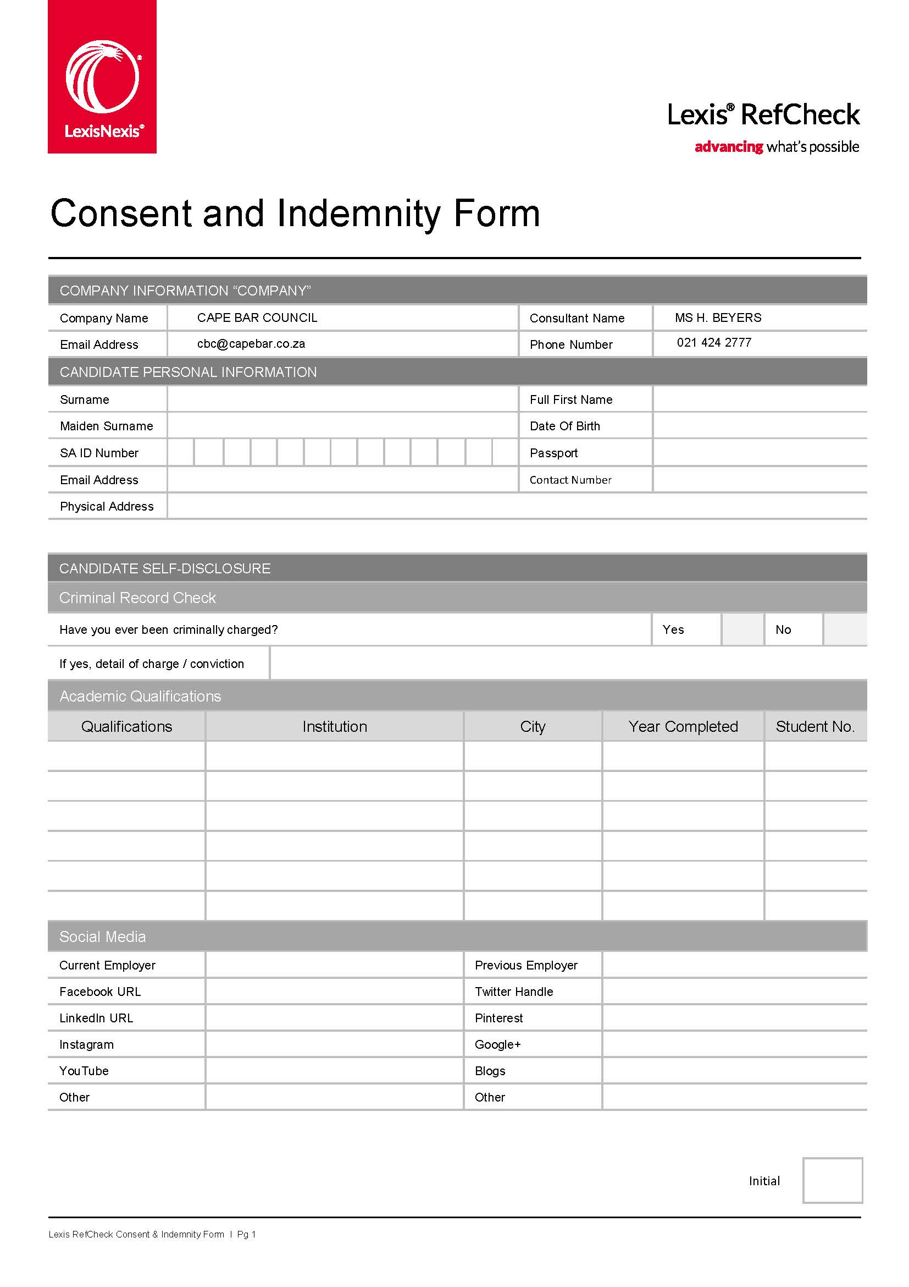
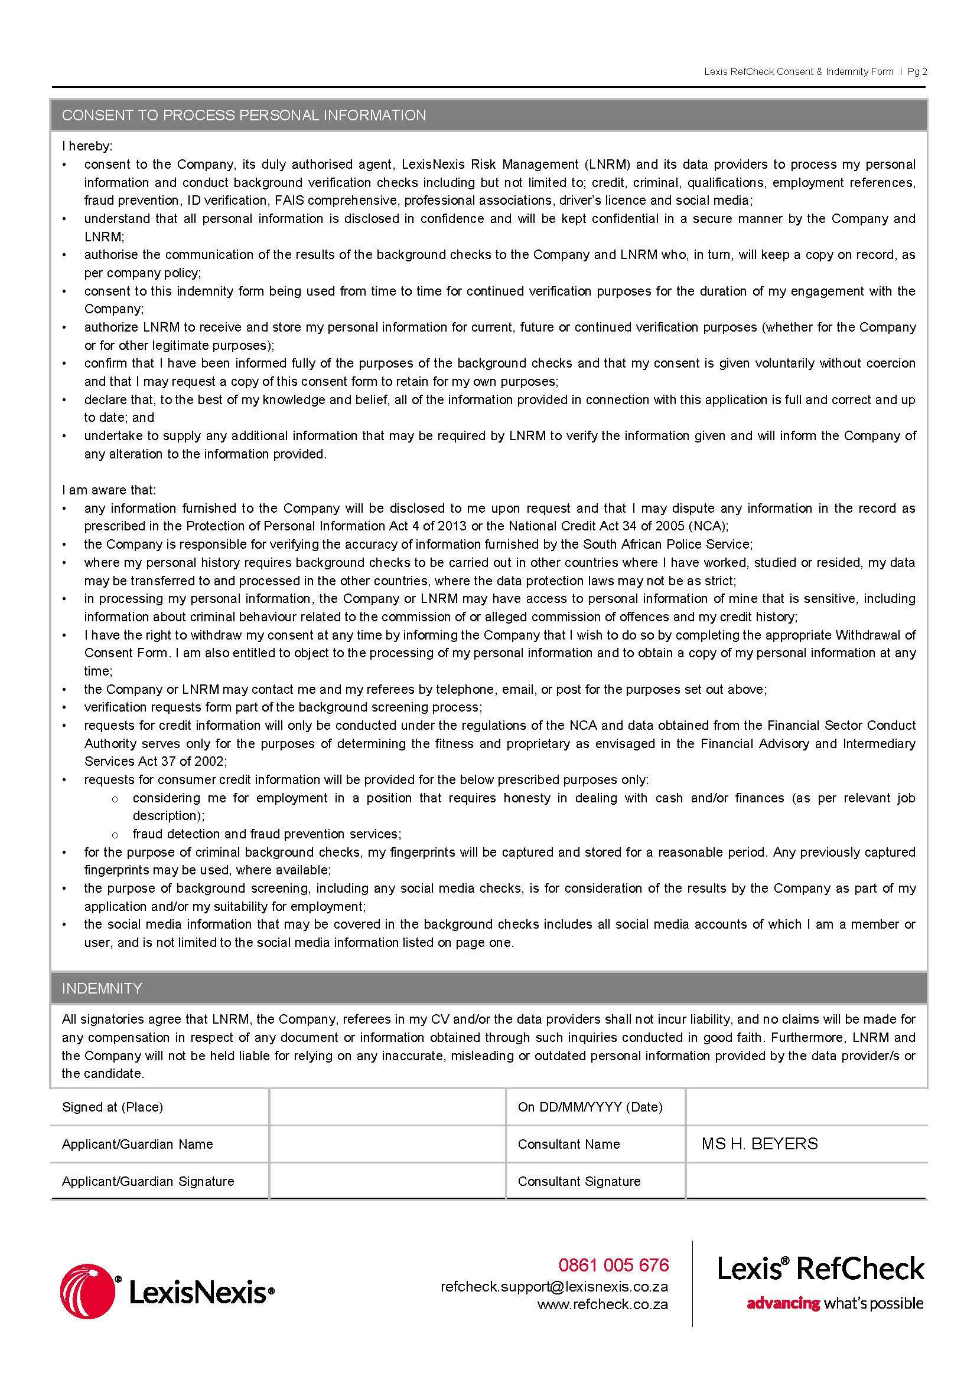

Schedule

HOW TO OBTAIN AN AFISWITCH FINGERPRINT CLEARANCE CERTIFICATE:
