See information schedule paras 81-82. |   APPLICATION FORM  PART 1 OF 2  Schedule 1, entitled ‘Information for Applicants’ (which commences at para 53 - ‘the information schedule’), constitutes an integral part of this application form. The information schedule sets out necessary requirements and instructions for the proper completion of this form and submission of your application. It is accordingly essential that you read and understand its contents and comply with the instructions. Kindly do so before you start filling in this form and before you direct any questions to the Cape Bar about the application process.  NO LATE APPLICATIONS WILL BE ACCEPTED, AND INCOMPLETE APPLICATIONS WILL BE REJECTED.  YOU MUST: COMPLETE THE FORM COMPLETELY, ACCURATELY AND HONESTLY; ATTACH EVERY DOCUMENT REQUIRED; AND SUBMIT BEFORE THE DEADLINE.  AN APPLICATION WILL NOT BE REGARDED AS COMPLETE IF THE NECESSARY SIGNATURES AND INITIALS HAVE NOT BEEN INCLUDED.  THE DEADLINE FOR APPLICATIONS FOR PUPILLAGE FOR 2026 IS AT 12:00 ON THURSDAY, 31 JULY 2025. NO APPLICATION WILL BE ACCEPTED AFTER THAT, AND NO INCOMPLETE APPLICATION SUBMITTED BY THE DEADLINE MAY BE SUPPLEMENTED AFTER THAT DATE AND TIME.  Your application comprises two parts: (a) this application form (part 1 of 2) AND (b) a signed and completed official applicant’s declaration (part 2 of 2). You must submit both.
  Attach
  photo
  here
  (Glued, not stapled, or electronically pasted)
 | I hereby apply for the following at the Cape Bar (pick one):
Click the appropriate checkbox.  An advocate applying for membership of the Cape Bar must meet the eligibility requirements in information schedule para 75.  Associate membership is only available to members practising in George or Knysna. |  | ☐ full membership  or
 |  | ☐ associate academic membership  or |  | (Complete Part A (‘ALL’)  and Part B (‘MEMBER’).)
☐ associate membership

or
 |  | ☐ pupillage |  | (Complete Part A (‘ALL’) and  Part C (‘PUPIL’).)
ALL applicants must complete Part A (even if you have done so in a previous application). | PART A: ALL APPLICATIONS  Name of applicant
ALL | - Full name(s) and surname:  ………………………………………………………………………….…………………..……  (Official first, middle and last names, e.g. ‘Susanna Nosiviwe Zulu’)
ALL | - First name which you prefer colleagues to call you: ………..…………………….…….…  (E.g. ‘Susan’)
 | Personal particulars of applicant
ALL  See information schedule paras 71-73.  You must provide an email address: correspon-dence will be sent to that address only. | - Home address: …………………………………………………...........................................  …………………………………………………………………………………………………....  ………………………………….........................… Postal code: ….....................................  Phone No: ......................................... Cell: ....................................................................  Email address: ……………………………………………...………………..…………………
ALL | - Postal address: …………………………………………………...........................................  …………………………………………………………………………………………………....  ………………………………….........................… Postal code: ….....................................
ALL | - Work address: …………………………………………………………………………………..  ……………………………………………………………………………………………………..  …………………………………..… Phone No: ………………………………………..………
ALL | - Date of birth: ……………………………………………………………………………………..
ALL | - Identity number: …………………………………………………………………………………
ALL  In respect of the questions on nationality, race, sex and disability, see information schedule para 74. | - Nationality:………………………………………………………………………………………..
  - If you are a South African citizen, how did you obtain South African citizenship?
☐ by birth or descent ☐ by naturalisation

  - If you are a South African citizen by naturalisation, on what date did you obtain South African citizenship? ..…………………………………….………

  - If you are not a South African citizen, provide full particulars of your immigration status and your right to reside in South Africa:

……………………………………………………………………………………………..

ALL | - Race: ☐ African ☐ Coloured ☐ Indian ☐ White
ALL | - Sex: ☐ Female ☐ Male
ALL  See question in para 43.5. | - Are you disabled? ☐ Yes ☐ No
 | If so, provide details: ………………………………..……………...………………...………..
ALL | - Do you need this application to be treated confidentially in regard to your current employer? ☐ Yes ☐ No
ALL  Your date of enrolment as an advocate will be different from your date of admission if your enrolment was converted from attorney to advocate by the LPC.  In order to convert your enrolment, you must inter alia have rights of appearance in the High Court and complete an accredited advocacy training course. The Cape Bar cannot guarantee that its course will be accredited by the LPC, see information schedule para 56.  Persons who completed their LLB degree before the Legal Practice Act came into effect on 1 November 2018, may apply for admission in terms of section 115 of the Act, see information schedule para 55. | Admission as a legal practitioner, enrolment as an advocate and previous pupillage  - If you are currently admitted as a legal practitioner and enrolled as an advocate:  - Date of and division where you were admitted as a legal practitioner:  …….…………………………………………………………………………..  - Date on which you were enrolled as an advocate by the Legal Practice Council:  …….…………………………………………………………………………..  - If you are currently admitted as a legal practitioner and enrolled as an attorney:  - Date of and division where you were admitted as a legal practitioner:  …….…………………………………………………………………………..  - Do you have rights of appearance as an attorney in the High Court?  ☐ Yes ☐ No  - Do you intend on applying to the Legal Practice Council to convert your enrolment from attorney to advocate on the completion of the Bar’s advocacy training course?  ☐ Yes  ☐ No. If no, when you will apply to convert your enrolment:  …….…………………………………………………………………………..  - If you are not currently admitted as a legal practitioner, do you intend on applying for admission as a legal practitioner and enrolment as an advocate on completion of pupillage?  ☐ Yes  ☐ No.  If no, when you will you apply for admission as a legal practitioner?  …….…………………………………………………………………………..
ALL | - Apart from the answer provided in paras 13-14 above, give particulars of any previous–  - admission as a legal practitioner or application for admission as a legal practitioner:  ………..…………………………………………………………………………………..
  - removal or suspension from the roll of attorneys or advocates:

………..…………………………………………………………………………………..

  - membership of any Bar or application for membership of any Bar:

………..…………………………………………………………………………………..

  - pupillage served at any Bar or pupillage applied for at any Bar:

………..…………………………………………………………………………………..

 | References
ALL | - Please furnish the name and contact details of two persons (preferably local persons) to whom the Cape Bar Council can refer:
  - Name: ……………………………..…………………………………………………….

Address: …………………………………..…………………………………………….

………..…………………………………………………………………………………..

 | Phone No: …………………………………………..………………………………….
 | E-mail: ……………………………………………………………………………….
 | - Name: ………………………………………………………………………………….
Address: ………………………………..……………………………………………….

………..…………………………………………………………………………………..

 | Phone No: ……………………………..……………………………………………….
 | E-mail: …………………………………….…………………………………………….

Only applicants for membership must complete  Part B | PART B: APPLICATION FOR MEMBERSHIP
MEMBER | - Have you successfully completed all requirements of pupillage (including passing the NBEB examinations and completing the required period of pupillage)?  ☐ Yes ☐ No  - If no, provide full details of the outstanding requirements or your exemption:  ………………………………………………………………………..…………………………..  ………………………………………………………………………..…………………………..
MEMBER  Members from constituent Bars need not submit proof of pupillage | - Have you attached proof of you having successfully completed all requirements of pupillage or having been exempted from any such requirement?  ☐ Yes ☐ No
MEMBER | - Are you or have you been a member of any Bar?  ☐ Yes ☐ No  If so, provide the following details, including any period of absence from practice:
  Name of Bar | Date membership started | Date membership ended
MEMBER | - Do you intend to take up dual membership (i.e. do you currently hold membership at another GCB constituent Bar)?  ☐ Yes ☐ No  If so, at which Bar will you be paying your GCB membership?  ……………..…………………………………………………
MEMBER | - If you are applying for associate membership (keeping approved chambers in George/Knysna), at which approved chambers do you intend to hold chambers?  ……………..…………………………………………………
MEMBER  This will be included in your profile on the Cape Bar’s website. See the website for examples. | - What are your main fields of practice or interest (e.g. criminal law, labour law, family law, competition law)?  ………………………………………………………………………..…………………………..  ………………………………………………………………………..…………………………..

Only applicants for pupillage must complete  Part C | PART C: APPLICATION FOR PUPILLAGE
 | Academic qualifications
PUPIL | - School where you matriculated ……………………………………….. Year ……………….
PUPIL | - Provide the following details of your tertiary academic qualifications, including ongoing studies:
 |  |  | LLB Degree / other qualification |  |  | Name of university / other institution |  |  |  |  | Date of graduation
 | * Please note that your application cannot be considered if you have not completed and successfully passed all subjects to qualify for an LLB degree as at the date of completion of this form.
 | Other academic achievements
PUPIL | - Provide details of any academic publications or any other academic achievements:  ………………..……………………………………………………………………………………  ……………………………………………………………………………………………………..
PUPIL  Answer with scrupulous honesty.  Do not leave out any period.  Add rows if necessary.  Do not simply refer to your CV.  The duration for a current activity should include the expected duration until the end of the calendar month in which you make application. | Background  - Provide the following details, in chronological order, of all your activities since leaving high school (including study, employment, occupation, travelling, unemployment, etc.) including your current occupation/activity:
  Institution / organisation / firm / company | Activity / position  Also state whether full time (FT) or part time (PT) | Dates |  |  | Duration (e.g. 3y 2m)
  Institution / organisation / firm / company |  | From  (yyyy-mm) | To  (yyyy-mm) |  | Duration (e.g. 3y 2m)
- Are you currently employed? ☐ Yes ☐ No
If so, please provide details of your current employment:

………………..……………………………………………………………………………………

………………..……………………………………………………………………………………

………………..……………………………………………………………………………………

PUPIL  If successfully completed, attach proof. | - Have you successfully completed your Attorneys Admission Examinations (or equivalent)? ☐ Yes ☐ No  If you have not yet done so, provide full disclosure of all subjects still to be passed or other requirements to be met:  ……………………………………………………………………………………………………..  ……………………………………………………………………………………………………..
PUPIL | - You are required to attach a testimonial from the dean of the law faculty that you attended or a certificate of conduct from the said faculty. If it is not possible to obtain such testimonial or certificate, you are required to state the reason for your inability to obtain it and this requirement may be waived by the Bar.  ……………………………………………………………………………………………………..
 | Applicants who are or were previously enrolled as attorneys:
PUPIL | - furnish full particulars including the name(s) of the firm(s) with which you were associated as an attorney:  …..………………………………………………………………………………………..
PUPIL | - what arrangements have been made for any firm of attorneys which practises under a name which includes yours to cease using your name?  …..………………………………………………………………………………………..
PUPIL | - are you entitled to any payment in respect of goodwill? If so, give full particulars:  …..………………………………………………………………………………………..
 | Applicants who are or were candidate legal practitioners / candidate attorneys
PUPIL | - Are you presently a candidate legal practitioner? ☐ Yes ☐ No
If so, furnish full particulars of the dates involved, name(s) of the attorney(s) and name(s) of the firm(s):

……………………………………………………………………………………………………..

PUPIL | - Were you ever previously a candidate attorney / articled clerk/ candidate legal practitioner? ☐ Yes ☐ No
If so, furnish full particulars of the dates involved, name(s) of the attorney(s) and name(s) of the firm(s):

……………………………………………………………………………………………………..
PUPIL | Relevant previous experience and skills  - Provide details of any previous legal experience other than that set out in the table in para 27 above:  ……………………………………………………………………………………………………..  ……………………………………………………………………………………………………..
PUPIL | - Provide details of any community service which you have performed, and specify whether it was done as part of LLB or other university coursework:  ……………………………………………………………………………………………………..  ……………………………………………………………………………………………………..  ……………………………………………………………………………………………………..
PUPIL | - If you are or were a legal practitioner, estimate what percentage of your practice involved litigious work:  %
PUPIL | - Indicate your level of proficiency in the following computer applications and activities:
 |  |  |  |  |  |  | unskilled |  | beginner | intermediate |  | advanced
 |  | Typing |  |  |  |  | ☐ |  | ☐ | ☐ |  | ☐
 |  | Microsoft Word |  |  |  |  | ☐ |  | ☐ | ☐ |  | ☐
 |  | Microsoft Excel |  |  |  |  | ☐ |  | ☐ | ☐ |  | ☐
 |  | Jutastat/LexisNexis electronic research |  |  |  |  | ☐ |  | ☐ | ☐ |  | ☐
 |  | Internet research |  |  |  |  | ☐ |  | ☐ | ☐ |  | ☐
 |  | Converting paper/documents to PDF |  |  |  |  | ☐ |  | ☐ | ☐ |  | ☐
PUPIL | - Do you have a drivers licence?  ☐ Yes ☐ No  If so, what code(s): …………………
PUPIL | - Will you still be in the employ of any person/institution at the commencement of pupillage? ☐ Yes ☐ No
If so, furnish full particulars (including any remuneration receivable by you and the date upon which your employment will finally terminate).

……………………………………………………………………………………………………..

……………………………………………………………………………………………………..

PUPIL | - Give particulars of any other applications for pupillage next year which you have made or intend to make:  ……………………………………………………………………………………………………  …………………………………………………………………………………………………….
PUPIL | - Have you previously commenced pupillage at any Bar?  ☐ Yes ☐ No  If so:
 | - How many times did you commence pupillage? ………………………………….
 | - Did you:
 |  |  |  | ☐ fail the NBEB examinations outright (without an oral or supplementary examination) | ☐ fail an oral or supplementary examination |  |  | ☐ other, explain:  ……………………………..………  ……..………………………………
  - What were the reasons for you failing the examinations or failing to complete pupillage?

………..…………………………………………………………………………………..

  - What steps do you consider that you will need to take in order to complete the examinations successfully?

………..…………………………………………………………………………………..
  - Do you have any disability/condition that will prevent you from writing the NBEB examinations in the ordinary course (e.g. not by hand, electronically, or requiring extra time)? ☐ Yes ☐ No
If so, please provide details:

………..…………………………………………………………………………………..

………..…………………………………………………………………………………..

………..…………………………………………………………………………………..

PUPIL  The Cape Bar will use your answer to assess among other things your knowledge of the work of an advocate, your writing skills and your ability to concisely convey an idea. | Motivation  - In fewer than 150 words, explain why you believe you would make a good advocate.  ……………………………………………………………………………………………………..  ……………………………………………………………………………………………………..  ……………………………………………………………………………………………………..  ……………………………………………………………………………………………………..  ……………………………………………………………………………………………………..  ……………………………………………………………………………………………………..  ……………………………………………………………………………………………………..  ……………………………………………………………………………………………………..  ……………………………………………………………………………………………………..  ……………………………………………………………………………………………………..  ……………………………………………………………………………………………………..  ……………………………………………………………………………………………………..  ……………………………………………………………………………………………………..  ……………………………………………………………………………………………………..  ……………………………………………………………………………………………………..  ……………………………………………………………………………………………………..  ……………………………………………………………………………………………………..  ……………………………………………………………………………………………………..  …………………………………………………………………………………………………….
PUPIL  See information schedule paras 94 - 95 | Pupillage  - Do you wish to apply for exemption from any of the requirements of pupillage? ☐ Yes ☐ No  If so, indicate which requirement or what period, and why:  ……………………………………………………………………………………………………..
PUPIL  See information schedule paras 96-98. | - Do you have any preference as to who your pupil mentor should be?  ☐ Yes ☐ No  If so,  - give his or her name:  ……………………………………………………………………………………………………..  - have you asked this particular advocate to be your mentor and what was their response?  ……………………………………………………………………………………………………..  - motivate your reason for wanting to do pupillage with this particular advocate (include information about any professional or other relationship):  ……………………………………………………………………………………………………..  ……………………………………………………………………………………………………..
PUPIL  See information schedule para 102. | - What financial arrangements have you made for your pupillage? …………………………  ……………………………………………………………………………………………………..  ……………………………………………………………………………………………………..  ……………………………………………………………………………………………………..
PUPIL | - Can you afford the training fee and will you meet the payment deadlines described in information schedule para 88?  ☐ Yes ☐ No
PUPIL  See information schedule para 90. | - If not, have you applied for a full or partial subsidy or deferment or instalment payment of your training fee?  ☐ Yes ☐ No
PUPIL  See information schedule paras 99-103. | - Will you require financial assistance to participate in the pupillage programme?  ☐ Yes ☐ No
PUPIL  See information schedule paras 104-105.  For an extensive motivation or explanation, use separate page(s).  Add rows if necessary. | - Do you have any personal, professional or other commitments which may impact on your ability to devote your full-time attention to pupillage and/or which may require you to be absent from chambers during any business hours in your year of pupillage?  ☐ Yes ☐ No  If so, provide the following information
  Nature of the commitment | Likely impact on pupillage | Time(s) and date(s) of any expected absence from chambers during business hours

 | After pupillage
PUPIL  Answer with scrupulous honesty.  See information schedule paras 106-109 | - Do you intend to practise as an advocate and as a member of a Bar on completion of your pupillage?  ☐ Yes ☐ No
  - If the answer is ‘no’, set out details of what you propose to do:

………..…………………………………………………………………………………..

………..…………………………………………………………………………………..

  - If the answer is ‘yes’, when do you intend to start practice and where?

………..…………………………………………………………………………………..

SCHEDULE INFORMATION FOR APPLICANTS
(‘the information schedule’)

INFORMATION ABOUT PART A: ALL APPLICATIONS

Risk concerning admission as legal practitioner and / or advocate, as the case may be

- The Cape Bar is a voluntary association of advocates. Accordingly, you must be admitted as a legal practitioner by the High Court and enrolled as an advocate by the Legal Practice Council in order to become a member of the Cape Bar. You may apply to become a member of the Cape Bar upon completion of pupillage. If on completion of pupillage you are not yet admitted as a legal practitioner and enrolled as an advocate, your application for membership will only be considered once you have been so admitted and enrolled.

- If you are not yet admitted and enrolled as a legal practitioner, and obtained your LLB degree after 1 November 2018, the following applies to you:

  - Section 26 of the Legal Practice Act 28 of 2014 (“the Act”) provides that a person qualifies to be admitted and enrolled as a legal practitioner if that person has, among other things, undergone all of the practical vocational training requirements prescribed by the Minister of Justice.

  - Please note that pupils who were neither admitted and enrolled nor entitled to be admitted and enrolled as an attorney or an advocate on 1 November 2018 (pupils who only received their LLB after this date) will have to serve under a practical vocational training contract for a full twelve months before they may be admitted and enrolled as advocates. As a consequence, these pupils will be unable to appear in court, accept briefs from attorneys, and must complete a full twelve months’ pupillage.

  - If you fall into this category you will have to write and pass the admission exams administered by the Legal Practice Council (in addition to writing and passing the NBEB exams administered by the General Council of the Bar of South Africa (“the GCB”)).

- If you are not admitted and enrolled as a legal practitioner, and obtained your LLB degree before 1 November 2018: section 125 of the Act provides that you may apply to the High Court for admission as a legal practitioner and enrolment as an advocate if you meet the requirements for admission as an advocate under the now repealed Admission of Advocates Act 74 of 1964, regardless of whether you have completed practical vocational training. Please refer to Ex Parte: Goosen and Others 2019 (3) SA 489 (GJ).

- If you are admitted and enrolled as a legal practitioner and attorney, and hope to be enrolled as a legal practitioner and advocate:

  - Rule 30 of the rules issued under the Act requires you, among other things, to have rights of appearance in the High Court, and to attend a specialised advocacy training course (it is anticipated that the Legal Practice Council will accredit the Cape Bar to provide such training in 2025).

  - If the Cape Bar is granted accreditation, you may apply to the Legal Practice Council to convert your enrolment from attorney to advocate, in terms of section 32 of the Act (“conversion”). In the past, pupils have been able to apply for conversion after completion of the GCB Advocacy Training Course – usually conducted for Cape Bar pupils in July.

  - If you obtained your LLB degree before 1 November 2018, you may alternatively apply for your name to be removed from the roll of attorneys and for admission as an advocate – please have regard to South African Legal Practice Council v Alves and Others 2021 (4) SA 158 (SCA).

- Once admitted and enrolled as an advocate, you must hand a copy of your admission certificate (as proof of admission as an advocate) to the Administrative Officer of the Cape Bar.

- In consequence of what is set out in paras 54 and 56.1 above, applicants accepted as pupils therefore assume the risk that upon successful completion of pupillage they may nevertheless be unable to be admitted and enrolled as a legal practitioner and / or advocate, and therefore unable to become a member of the Cape Bar.

Information required from every applicant, including members of other bars

- Experience has shown that the process of assessing applications must be both thorough and consistent. For instance, previous applicants have been found to be unqualified or to have failed to disclose a criminal record or to have had a history of unprofessional conduct. Thoroughness requires the detailed information requested in this application form, which enables the Cape Bar to verify compliance with the requirements for membership. Consistency involves vetting every applicant. To exempt a category of applicants from thorough vetting would be arbitrary and discriminatory. Hence, detailed information is required even from an established and long-standing member of another bar. This thorough and consistent process protects the integrity of the Cape Bar – in the interests of the public, the administration of justice and all members of the Cape Bar.

Completion and submission of application

- Electronic applications are not accepted. Applications must be submitted in hard copy, either in person, or by courier (see para 82 below).

- Before filling in and submitting this application, check the date in the footer against the Cape Bar’s website to ensure that the application form is the current version. Only the current version will be accepted.

- You are requested, but not required, to complete the application form in bold typewriting on a word processor (Microsoft Word). For this purpose, you may download an electronic version of the application form from the website of the Cape Bar, www.capebar.co.za.

- If you are completing the application form on a word processor and the form does not provide enough space for you to fully answer any particular question then continue typing each answer until it is complete and delete any dotted lines.

- If you are completing the application form by hand and the form does not provide enough space for you to fully answer any particular question then use a separate page. If you use a separate page, ensure that (a) this fact is clearly stated under the relevant question on the application form itself and (b) the answer on the separate page is headed with the corresponding question number.

- The following annexures must be attached to this application (see the advice in para 69 about retaining certified copies):
 | - A recent passport photograph securely glued (but not stapled) to the designated space on page 1. Be advised that if your application is successful, this photograph will be distributed to other members of the Cape Bar and Judges of the High Court, and will be displayed on the Cape Bar’s website. Ensure that your appearance is sufficiently professional to be suitable for those purposes; | ☐
 | - A completed and signed official declaration; | ☐
 | - A certified copy of your identification document or passport; | ☐
 | - If you are a South African citizen by naturalisation, a certified copy of the document(s) that prove the date that you obtained South African citizenship; | ☐
 | - If you are not a South African citizen, a certified copy of the document(s) that prove your immigration status (eg permanent residence); | ☐
 | - A certified copy of each of your degree certificate(s) listed in question 25 (if you have graduated); | ☐
 | - If you are a legal practitioner (whether enrolled as an attorney or an advocate) a certified copy of a certificate of good standing from the Legal Practice Council (which should not be older than 3 months); | ☐
 | - A certified copy of the court order admitting you as a legal practitioner by the High Court (if you have been admitted); and | ☐
 | - A certified copy of the certificate issued by the Legal Practice Council confirming your enrolment as an advocate or attorney (if you are so enrolled). Please note this is a different document to 65.7 above. | ☐
 | - The following documents must be delivered by you to the Cape Bar (in the manner set out in paras 67 and 68 below) together with the annexures referred to in para 65 above:
 | - A completed and signed original LexisNexis consent form: see Schedule 2. This is to enable the Cape Bar to perform a credit report check, ID verification, validation and fraud listing and a fraud, corruption or theft investigation. | ☐
 | - A Fingerprint Clearance Certificate which is less than three months old as verification of your criminal record status.  (For this process, you must follow the instructions on Afiswitch.com, in order to obtain a certificate from one of its service providers listed on their website. This is to be done at your own cost.) Please note no other clearance checks, aside from Afiswitch, are accepted. | ☐
 | - This information schedule, each page of which must be initialled. | ☐
 | - If this is an application for membership, the items listed in para 76. | ☐
 | - If this is an application for pupillage, the items listed in para 80. | ☐

- Applications both for membership and for pupillage at the Cape Bar must be directed to:
The Administrative Officer
Cape Bar Council
Ground floor
Huguenot Chambers
67 Keerom Street
Cape Town 8001

- An application will be considered only if it is received in hard copy (i.e. not by email) with all required annexures at the office of the Administrative Officer of the Cape Bar. The application form is required in hard copy, inter alia, to ensure authenticity of your signature and quality of your photo.

- Please do not provide a covering letter, index, ring-bind, staple, label or put the application form in folders. Rather use a bull-dog clip to keep the application together. Any ‘extras’ to the application will be removed and discarded.

- You are strongly advised to retain a copy of your application and additional certified copies of all supporting documents in case you need to make another application. For example, an applicant who successfully applies for and completes pupillage will again need to annex many of the same documents to their membership application in due course. Note that a copy of a certified copy is not a certified copy.

Notification of any change to contact details

- You are required to immediately notify the Administrative Officer of the Cape Bar of any changes to your contact details (address, phone number(s) and e-mail address).

- You will be deemed to have received a communication sent to your address or e-mail address on record. For example, after a notice of the date, time and venue for any interview has been sent to your address or e-mail address on record, the Cape Bar will not follow up with you to check whether or not you in fact received such notice.

- Your duty to immediately notify the Administrative Officer of the Cape Bar of any changes to your contact details lasts throughout your period of pupillage, should your application be successful and/or your membership of the Cape Bar.

Demographic information

- Particulars about race, sex, disability status and nationality are required for statistical reporting and the promotion of transformation in the advocates’ profession, including the promotion of preferential briefing. In the case of applications for pupillage, nationality, race, sex and disability status enable the Cape Bar to apply its policy of preferring historically disadvantaged individuals (see para 83 below).

INFORMATION ABOUT PART B: APPLICATION FOR MEMBERSHIP

- To be eligible for membership of the Cape Bar you must:
  - be duly admitted as a legal practitioner by the High Court of South Africa and enrolled as an advocate by the Legal Practice Council;
  - intend to practise as an advocate in the Western Cape;
  - be a fit and proper person for membership;
  - have successfully completed the admission examinations administered by the Legal Practice Council (if applicable to you);
  - have successfully completed the requirements of pupillage of the Cape Bar or having been exempted by the Cape Bar from any such requirement, which include having passed the NBEB examinations and having completed the prescribed pupillage requirements at the Cape Bar or at another Bar recognised by the Cape Bar; and
  - comply with the remaining requirements of the Constitution of the Cape Bar or determinations of the Cape Bar Council, such as those relating to the keeping of chambers.

- In addition to the annexures listed in para 65, the following annexures must be attached to an application for membership:
- If you are or were a member of another Bar (including the Cape Bar), a letter of good standing (which should not be older than 3 months) from each Bar indicating the exact dates of such membership(s); | ☐
- If you were not previously a member of a GCB constituent Bar, or unless you are unable to do so for good cause shown, proof of you having successfully completed the requirements of pupillage or having been exempted from any such requirement, as contemplated in para 75.5; and | ☐
- If you are a silk, a certified copy of your Letters Patent. | ☐

- Your application for membership:
  - must comply with the requirements of the Cape Bar Council’s Constitution (see the ‘forms and documents’ tab at www.capebar.co.za);
  - will not be considered if it is incomplete or does not have all the required annexures;
  - if not delivered in person, must be delivered by courier to the Cape Bar’s physical address specifying ‘door delivery’ (or equivalent) and not for counter;
  - if it is received less than ten days before a meeting of the Cape Bar Council, will be held over until the following meeting (the Council’s scheduled meeting dates are on the website, but are subject to change without notice).

- The Cape Bar will notify you in writing of the outcome of your application.

- It is a condition of full membership and of associate membership of the Cape Bar that you must apply for and keep chambers approved and/or allocated by the Cape Bar Council.
  - If your application for full membership or associate membership is approved, the Bar Council will afford you two months within which to take up chambers. Your name may be added to the membership list only when you have taken up chambers (and have duly signed the membership register).
  - You are advised to consider the above when timing the submission of your application.
  - If applying for full membership, you may contact the Cape Bar Council’s housing department (cbchousing@capebar.co.za) to ascertain the availability of chambers.

INFORMATION ABOUT PART C: APPLICATION FOR PUPILLAGE

Completion and submission of application for pupillage

- In addition to the annexures listed in para 65, the following annexures must be attached to an application for pupillage:
- A certified copy of testimonial from the dean of the law faculty that you attended or a certificate of conduct from the said faculty (unless you have applied, in terms of question 30, for the Cape Bar to waive this requirement); | ☐
- A certified copy of your certificate(s) showing successful completion of any Attorneys Admission Examinations (or equivalent); | ☐
- A certified copy of any certificate of completion of the programme in Legal Practice at the School for Legal Practice (if applicable); | ☐
- A certified copy of your academic record showing all marks or other results obtained towards your LLB degree. Unlike your degree certificate or a transcript of academic results, an academic record shows all your university results including, for example, those results for subjects that you may have initially failed but which you subsequently passed. If you have obtained credits towards your LLB from courses done while studying for another degree or from a different university then attach academic records in respect of such other degree or other university. Without this information, the Cape Bar will not be able to assess your application. | ☐

- The closing time for applications for pupillage is 12:00 on the advertised closing date in the year preceding the year of pupillage. A working day is a day other than Saturday, Sunday or a public holiday.

- Save in exceptional circumstances, no application for pupillage received after the closing time will be considered. It is therefore in your interests to not leave the completion and submission of your application to the last minute. Rather ensure that the Administrative Officer of the Cape Bar has received your application well before the closing date. If you send your application by courier, you must send it for ‘door delivery’ (or equivalent) and not for ‘counter’.

Assessment of applications for pupillage

- The timeous submission of a complete application form does not guarantee that the Cape Bar will necessarily accept your application for pupillage.
  - If the number of applications for pupil membership of the Cape Bar exceeds the number of available places in any particular year, then some applications will, unfortunately, be turned down.
  - The selection criteria are: LLB results and other academic achievements, relevant previous experience, aptitude and motivation to be an advocate, nationality, race, sex and disability status. The order in which these criteria have been listed here do not necessarily indicate the weighting that they will be given.
  - The application and weighting of the abovementioned criteria will be in the discretion of the Cape Bar.
  - Irrespective of the number of available places, the Cape Bar may turn down your application if it decides that you are not a suitable candidate for pupillage.
  - To promote the transformation of the Cape Bar to better reflect the composition of society, preference may be given to applicants who are (a) African, Coloured or Indian; (b) female; or (c) disabled, provided that such applicants are a South African citizen by (i) naturalisation before 27 April 1994; or (ii) birth or descent.

- For your information, the Cape Bar’s criteria and process for selecting applicants for pupillage are set out in its pupillage selection policy, which is available on its website (www.capebar.co.za under the ‘forms and documents’ tab). The selection policy promotes transformation of the Cape Bar by giving preference to South African applicants who are black, female and/or disabled.

- You will be required to write a pupillage entrance examination to evaluate your aptitude to be an advocate. Details of the examination venue and time will be provided to you after you have submitted your application.

- The Cape Bar may require you to be interviewed prior to taking a decision on your application for pupillage and your failure to attend will be regarded as a withdrawal of your application. The interview will form an important part of the assessment process. An audio recording of the interview may be made without further notice.

- The Cape Bar will inform you of the outcome of your application for pupillage as soon as possible.

Training fee

- As a contribution to the costs of training and of administering the pupillage programme, unless subsidised, each pupil must pay the Cape Bar a training fee of R7,000. Unless you have applied for financial assistance, you must pay:
  - R1,500 within seven days of the Cape Bar offering you a place in the pupillage programme (see para 87), and
  - the remaining amount (R5,500) at the commencement of pupillage (see para 91).
  - Payment must be made to the Cape Bar by means of EFT. Use your last name, initial and pupillage as the reference (e.g. J James/Pupillage). The Cape Bar's banking details are as follows:

Account name: Cape Bar Council
Bank/Branch: FNB Adderley Street
Account no: 62104924891
Branch code: 201409
Payment reference: Surname/Pupillage

Proof of payment must be emailed to cbc@capebar.co.za AND cbcacc@capebar.co.za.

- Non-compliance will cause your offer to lapse and your place will be offered to another applicant. If you have not paid the training fee and have applied for financial assistance, you will be provisionally accepted pending the finalisation of your financial assistance application.

- On application, the Cape Bar may subsidise the training fee in full or in part, defer payment, or allow payment in instalments for a limited number of pupils, depending on financial need and other relevant considerations. To apply, please fill in the financial assistance application form in Schedule 4.

Duration of pupillage

- Unless you are granted an exemption, pupillage commences on 15 January of each year (or the following business day if 15 January falls on a Saturday, Sunday or public holiday). Pupillage terminates on 31 December of each year or on such date as the Cape Bar may determine and notify to you.

- Should you be admitted to the pupillage programme but not fulfil the requirements of the programme, the Pupillage Committee of the Cape Bar may extend the period of your pupillage.

- On recommendation of its Pupillage Committee, the Cape Bar Council may terminate the pupillage of a pupil for any good reason, including:
  - misconduct or inappropriate conduct;
  - a failure to meet the compulsory requirements of the pupillage program; or
  - other conduct (whether or not such conduct constitutes a disciplinary offence) which disrupts, disturbs or interferes with the functioning or work of a court, the Cape Bar or the pupillage programme or any person including the pupil’s mentor, another member of the Cape Bar, another pupil or staff.

Exemption from the requirements of pupillage

- If you wish to apply for an exemption from any requirement of pupillage, fully motivate all the facts relied upon to support your application. Use separate page(s) to do so.

- For your information:
  - Exemptions are granted sparingly.
  - In principle, the period of a programme for pupillage will be the same for pupils who have not yet qualified as legal practitioners as for pupils who have already qualified as legal practitioners, viz. 12 months.
  - Provision for partial exemption from this requirement is as follows :-
    - No-one may be exempted from any of the requirements of pupillage if he or she has not practised as a legal practitioner for at least 4 years.
    - A legal practitioner who has practiced as such for a period of at least 4 years may apply to the Cape Bar Council for partial exemption from the requirements of pupillage, provided that the Cape Bar Council may not exempt anybody from the requirements of having to:-
(a) pass the National Bar Examination; or
(b) satisfactorily attend advanced practical advocacy training.
  - Notwithstanding anything contained above, the Annual General Meeting of the GCB has the power to exempt any person from the requirements of pupillage.

Pupil mentor

- You are encouraged to ascertain from a member of the Cape Bar whether that member would be willing to be your mentor in the event that your application succeeds. Note that senior counsel are never appointed as mentors and that, absent prior relevant experience, members of less than five years standing are generally not appointed as mentors.

- The decision on the allocation of your mentor rests with the Cape Bar and while your preference, if any, will be taken into account, the fact that a member may be willing to be your mentor does not necessarily mean that you will be allocated to that member. Likewise, the fact that a member may be willing to be your mentor does not necessarily mean that you will be offered a place in the pupillage programme.

- It is not essential that you arrange for someone to be your mentor. If you do not or cannot arrange for an advocate to be your prospective mentor, the Cape Bar will allocate a suitable member to be your mentor.

Financial assistance during pupillage

- Pupils do not receive a salary during pupillage. Pupillage is a period of training which the Cape Bar provides to successful applicants at no charge apart from the relatively limited training fee. If accepted for pupillage, you are entirely responsible for meeting your own financial needs, both personal and those related to the proper completion of pupillage. The Legal Practice Council may determine that remuneration, an allowance or a stipend is payable to pupils. If the Legal Practice Council so determines, but fails to fund such remuneration, allowance or stipend, then the Cape Bar may not accept applicants for pupillage and reserves the right to cancel pupillage at any stage.

- The Cape Bar can provide limited financial assistance to some pupils during their pupillage. Note that the nature and amount of financial assistance available from the Cape Bar might be different to that available from another Bar.

- The grant of financial assistance is not a right. It is entirely discretionary. The Cape Bar will decide each application on a range of considerations including the merits of each individual’s application, an applicant’s financial needs, the availability of funds, transformation policy objectives (both race and gender), other relevant policy considerations and any other factors which the Cape Bar considers relevant at the time.

- An application for financial assistance will not prejudice your application for admission to the pupillage programme. It is in your interests that you fully disclose what financial arrangements you have made for your pupillage.

- Should you wish to apply for financial assistance, please fill in the financial assistance application form in Schedule 4. The following important conditions apply to the application for financial assistance:
  - financially deserving black and/or female applicants for pupillage may apply;
  - the warnings in the accompanying declaration which you must sign apply to applications for financial assistance;
  - every item in Tables ‘A’ and ‘B’ to Schedule 4 must be answered;
  - an incomplete application may not be considered;
  - your application for financial assistance will be kept confidential;
  - the application for financial assistance must accompany your application for pupillage;
  - if your financial circumstances improve at any stage change during pupillage you must inform the Secretary of the Cape Bar;
  - you will be notified before 15 December regarding the outcome of your application for financial assistance.

Fulltime commitment

- Pupillage is a demanding and intensive commitment – even for pupils who have previous legal practice experience. Pupils must devote themselves fulltime to pupillage obligations for the full year of pupillage, apart from any period of formal exemption granted to the pupil. Pupillage involves attending chambers and actively assisting in ongoing matters during business hours (weekdays, including recess, between the hours of approximately 08:00 and 17:00), and whenever else required by the mentor. In addition, pupils must do weekly exercises, advocacy training preparation and studying outside of chamber time. Other than official study leave, pupils may not take days off without permission from the Pupillage Committee, which is only granted in extraordinary circumstances.

- You are required to disclose any personal, professional or other commitments which may impact on your ability to comply with the requirement to devote your full-time attention to pupillage and/or be present in chambers during business hours in your year of pupillage.

Practice

- Once you have passed the NBEB examinations and completed your pupillage, you may apply to practise as a member of the Cape Bar. Practising as an advocate is both rewarding and demanding. This is not a salaried position, nor are your expenses covered. You will be solely responsible for setting up and maintaining your chambers as allocated by the Bar.

- The financial commitments are significant. Initial costs include robes, legal texts, office furniture, and computer equipment. Ongoing expenses include rental, floor fees, law report subscriptions, and other professional overheads. There is no guarantee of receiving briefs, and even when you do, income can be irregular. Managing cash flow - especially when expenses arise before fees are paid - can be particularly challenging.

- In effect, you will be operating as an independent business. This requires not only legal skill but also the ability to manage your practice effectively and sustainably.

- This information is provided to help you prepare, not to deter you. A successful career as an advocate depends on being realistic about the practical and financial demands of practice. It is your responsibility to inform yourself and plan accordingly.

--ooOoo--

Schedule
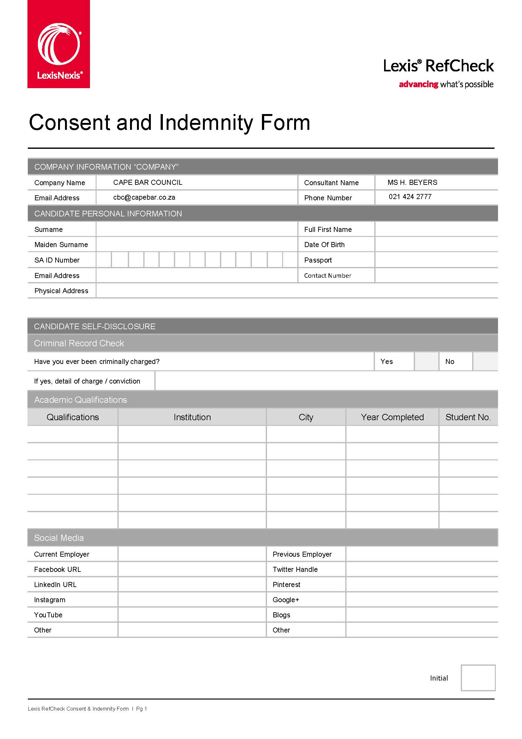
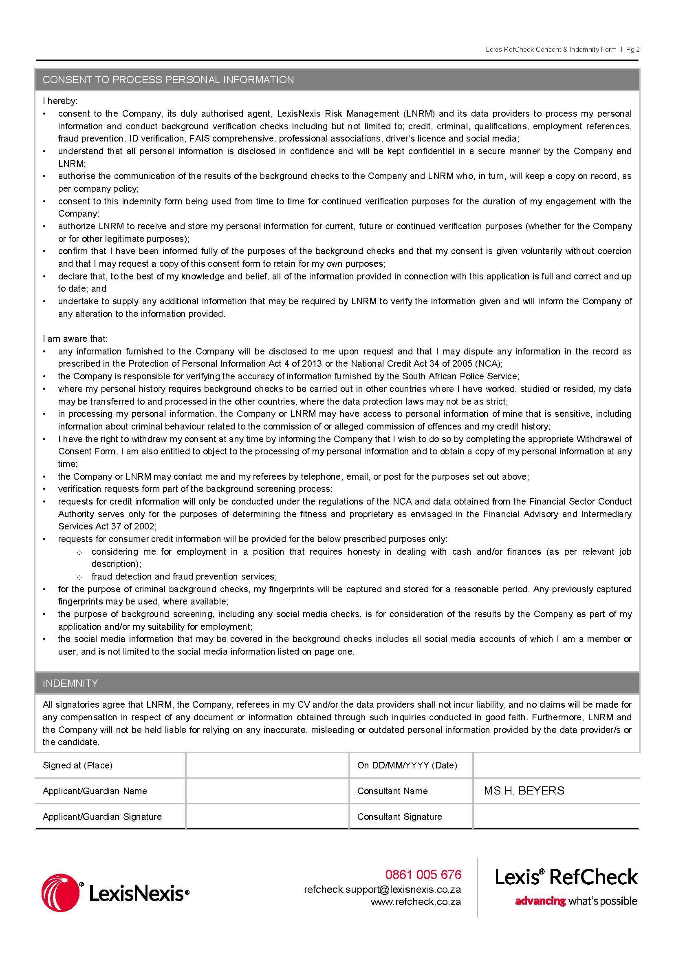

Schedule

HOW TO OBTAIN AN AFISWITCH FINGERPRINT CLEARANCE CERTIFICATE:
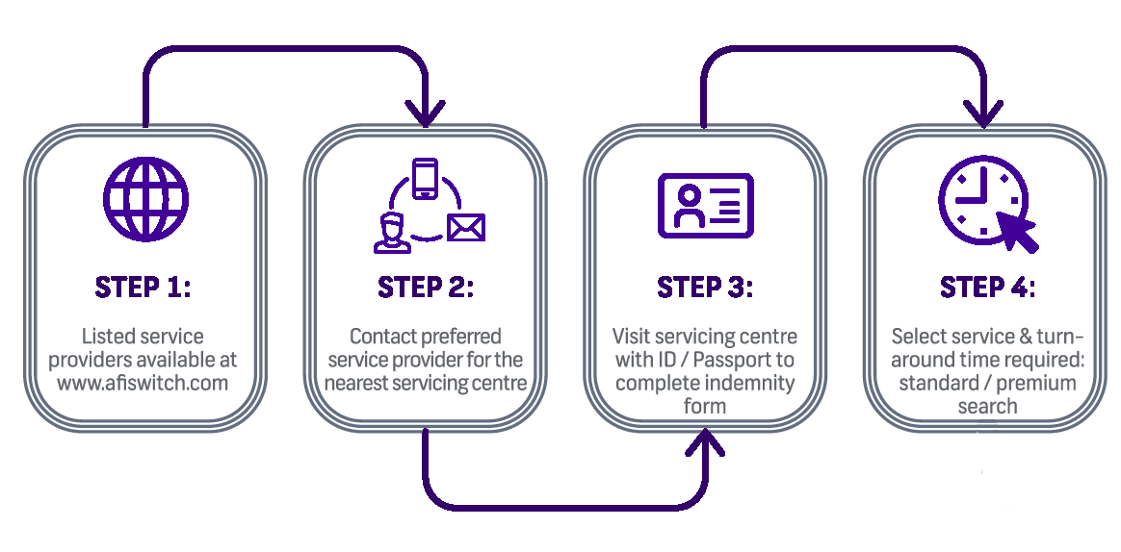

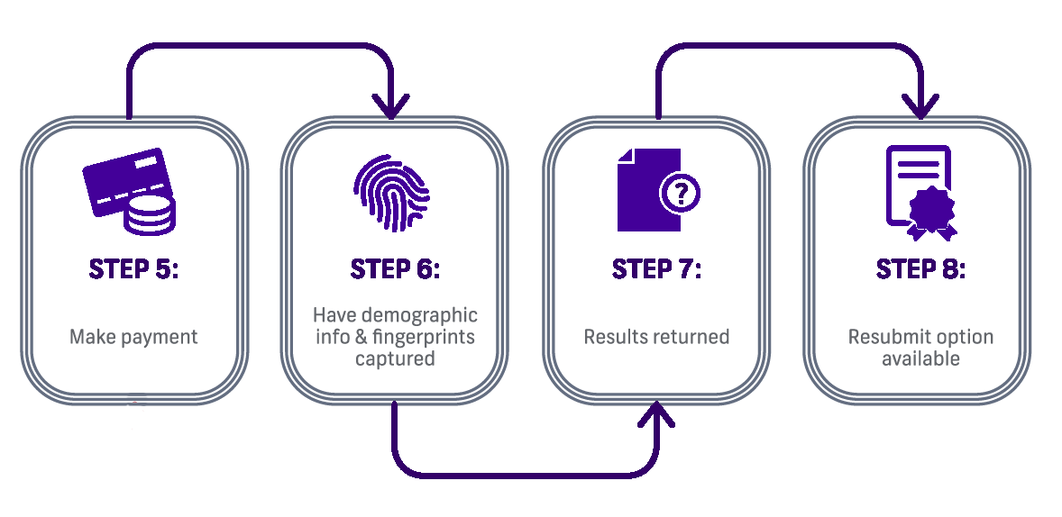

Complete the form in Schedule 4 only if you are applying both for pupillage and for financial assistance  Re training fee see para 88.  Re bursary see paras 99 to 103. | SCHEDULE APPLICATION FOR FINANCIAL ASSISTANCE FOR PUPILLAGE  A. Nature of application  - State what financial assistance you need (check the appropriate box(es)):  Training fee: full subsidy ☐  partial subsidy ☐ How much can you afford: R …………  deferred payment ☐ By what date can you pay: ……………  instalment payments ☐ How much per month can you afford?  …………………………………………....  Do you need a bursary? ☐ Yes ☐ No  B. Personal Particulars  - Address at which you will be residing during pupillage and with whom, if anyone, will you be residing  …………………………………………………………………………………………………..  ………………………………………………………………………………………………....
- Do you have access to a motor vehicle? If so, details of make and model?

………………………………………………………………………………………………....

- How do you intend travelling to chambers during pupillage?

…………………………………………………………………………………………………..

 | - Names of dependants (if any):
 |  | Name | Relationship | Age
 | C. Education
- How did you pay for your studies? Parental support / other ………………………….

If other, give particulars:

....................................................................................................................................

- If you received a bursary, loan or other sponsorship, give full details, including the total amounts:

....................................................................................................................................

....................................................................................................................................
- Did you have to repay loans/bursaries? If so are you still making payments and if so, how frequently and how much is each payment, and how much is still outstanding?

....................................................................................................................................

....................................................................................................................................

....................................................................................................................................
 | D. Previous employment
- Details of any benefits received from previous employment:

Pension: R………………………

Provident fund: R………………………

Other: R………………………

Please complete, in addition, Table ‘A’ below. | E. Financial Particulars  Personal Assets  - Describe any immovable property registered in your name: ………………………….  ....................................................................................................................................  VALUE: R…………..
- Do you or your spouse/partner have an interest in any business, including family business?

☐ Yes ☐ No

If so, provide full details of the name and type of the business(es), the nature and extent of the interest, including the amount of income derived from the business or the value of any other benefit:

....................................................................................................................................

- Are you the beneficiary of any trust(s)? If so, provide details:

....................................................................................................................................
- Estimate the value of your movable assets including clothes, jewellery, household furniture and appliances, books and legal text books

VALUE: R…………..

- Total savings / investments of any nature (formal, informal or investments into assets of any kind)

- yourself VALUE: R…………..

- your spouse / partner VALUE: R…………..

- parents VALUE: R…………..
 | Income
Attach certified copies of salary slips and three months’ bank statements to prove paras 124 - 130. | - What was your total pre-tax income for the past twelve months?  R………………………  Source(s) of pre-tax income for the past twelve months………………………………….
Indicate frequency of income (eg per month, per year) | - Your expected pre-tax income during your year of pupillage from all sources:  source amount  (a) ……………………………………………………… R………………………  (b) ……………………………………………………… R………………………  (c) ……………………………………………………… R………………………
- Your spouse/partner’s expected total pre-tax income during your year of pupillage:

R………………………

- Your father’s expected total pre-tax income during your year of pupillage:

R………………………

- Your mother’s expected total pre-tax income during your year of pupillage:

R………………………

- Have any other individuals provided you with financial support in the past five years and/or are able to do so now?
☐ Yes ☐ No

If so, describe the relationship of this/these individual(s) to you:

…………………………………………………………

What is their expected total pre-tax income during your year of pupillage:

R………………………

Attach certified copies of three months’ bank statements for each of these accounts or facilities. | - How many bank accounts or banking finance facilities do you have access to, whether in your name or not (including personal, business or otherwise)? …………………………..  - Provide the following details for each of those accounts and facilities:  Name of bank: …………………………...  Account number: ………………………..  Branch: ……………………………………  Main purpose(es) of account (eg. personal, business): …………………………
- Please note: you must attach certified copies of salary slips and three months’ bank statements to prove paras 119 to 125.

- Are you receiving, or have you applied for any other financial assistance? If so, from whom, and what is the amount?

(a) ……………………………………………………… R………………………

(b) ……………………………………………………… R………………………

(c) ……………………………………………………… R………………………

- Should your application for a bursary not be successful, how do you intend supporting yourself during your pupillage?

.…………………………………………………………………………………………………

…………………………………………………………………………………………………

FINANCIAL DECLARATION
in respect of Schedule 4

(This declaration is only to be completed if you are applying both for pupillage AND for financial assistance)

I declare that the information provided by me in this application for financial assistance, including Tables ‘A’ and ‘B’, is true and correct.

I undertake to advise the Cape Bar in writing in the event of any material change in the information supplied. I hereby grant approval to the Cape Bar to investigate the aforesaid information and hereby grant my consent to anybody approached to provide confidential information to the Cape Bar.

............................................. .............................................
APPLICANT’S SIGNATURE DATE

A witness must be a parent, guardian, spouse, partner or other person who can attest to the correctness of the financial information you have submitted. | FIRST WITNESS  Full name ...............................................................................................................  Residential address ................................................................................................  ................................................................................................................................  Relationship to applicant: .......................................................................................  .................................................... ......................................  SIGNATURE DATE  SECOND WITNESS  Full name ...............................................................................................................  Residential address ................................................................................................  ................................................................................................................................  Relationship to applicant: .......................................................................................  ................................................... ..........................................  SIGNATURE DATE

TABLE A: LIST OF ASSETS
 |  | YOURSELF | SPOUSE/  PARTNER | PARENTS
 | Realisable assets | R | R | R
 | Moveable assets | R | R | R
 | Immovable assets | R | R | R
 | Incorporeal assets | R | R | R
 | Bank accounts:
 | (a) ...........................................  (b) ...........................................  (c) ........................................... | R........................  R........................  R........................ | R.....................  R.....................  R..................... | R......................  R......................  R......................
 | Unit Trust account | R | R | R
 | Endowment policies | R | R | R
 | Motor vehicle | R | R | R
 | Time share | R | R | R
 | Other assets (give full details) | R | R | R
 | 1. | R | R | R
 | 2. | R | R | R

TABLE B: YOUR EXPECTED MONTHLY EXPENDITURE DURING PUPILLAGE
 |  |  | Self | Children | Spouse/  Partner | Parents | Total
 | Household Expenses
 |  | Bond/rent
 |  | Rates/water
 |  | Electricity
 |  | Domestic worker
 |  | Security
 |  | Household insurance
 |  | Home owner's insurance
 | Food and household items
 |  | Groceries
 |  | Toiletries
 |  | Cleaning materials
 | Telephone
 |  | Landline
 |  | Cell phone
 |  | Internet connection
 | Motor vehicle
 |  | Finance
 |  | Petrol
 |  | Licence
 |  | AA membership
 |  | Breakdown service
 |  | Insurance
 |  | Replacement of tyres
 |  | Repairs and service
 | Medical
 |  | Medical aid
 |  | Chemist - non-prescription medication
 |  | Chemist - excluding those covered by medical aid
 | Entertainment
 |  | Eating out and take-aways
 |  | Entertaining at home, including children's birthday parties and friends to stay
 |  | Videos/DVD's, movies and shows
 |  | Birthday and Christmas gifts
 |  | TV Licence
 |  | MNet/DSTV
 | Reading material, music, communications, recreation and hobbies
 |  | Newspapers, books, magazines
 |  | Children's books
 |  | CD's
 |  | Stationery
 | Personal expenses
 |  | Hair cuts etc.
 |  | Clothing, shoes and accessories
 | School expenses
 |  | School/crèche fees
 |  | School uniforms
 |  | School lunches
 |  | Extra-mural activities
 |  | Equipment and clothing
 |  | Aftercare/school holiday care
 |  | School outings
 |  | School books
 | Children's expenses
 |  | Pocket money
 |  | Hair cuts
 |  | Clothing
 |  | Babysitting
 | Maintenance obligations (provide name and relationship)
 | Sundry expenses (please set out)
 | TOTALS

DECLARATION UNDER OATH

(This declaration relates only to the application for financial assistance)

Signed and sworn at ..................................... on this ............day of ................................ 20......

The deponent:
- acknowledged that she/he knows, understands and confirms the correctness of the contents of this application for financial assistance including Tables ‘A’ and ‘B’;
- confirmed that she/he has no objection to taking the prescribed oath;
- confirmed that she/he considers the prescribed oath as binding on her/his conscience.

....................................................

COMMISSIONER OF OATHS

Full names: …………………………………………………………………….…
Designation and area: ………………………………………………………………….……
Street address: ………………………………………………………………….……
………………………………………………………………….……
………………………………………………………………….……

